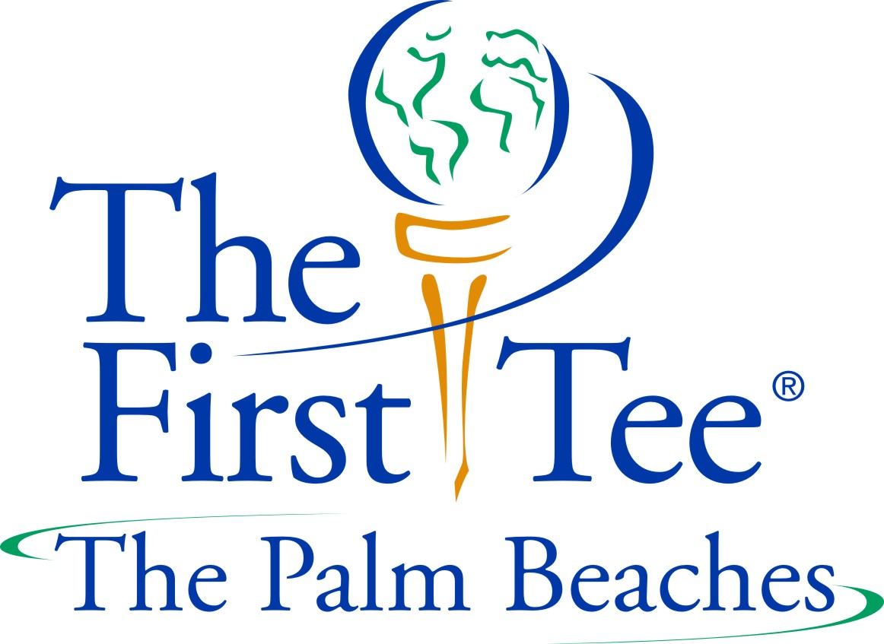

Participant Registration Form
Custom Fit Golf Academy
John Prince Golf Learning Center
4754 S. Congress Ave. Lake Worth, FL 33461
Tel.: 561-628-7354 / 561-966-6666

(PLEASE PRINT NEATLY ALL INFORMATION) TODAY’S DATE: ___________________

PROGRAM: SPECIAL NEEDS CLASS – Email Registration Form to: nancy@nancystuartgolf.com / call Nancy: 561-618-7354 or CFGA at John Prince Golf Learning Center: 561-966-6666

PARTICIPANT’S NAME: ____________________________________________________________________________________________________
Last First Middle

SCHOOL: _____________________________________GRADE LEVEL_________ETHNICITY____________________________________________

GENDER: _____Female _____Male AGE:___________DATE OF BIRTH:______________________________________________________

ADDRESS:________________________________________________________________________________________________________________

CITY________________________________________________________STATE________ZIP____________________________________________

PARENT CELL PHONES FOR EMERGENCY TEXTING: ( ) ( ) _____________________________________________

PLEASE PRINT PARENT EMAIL CAREFULLY: ____ ____ ____ ____ ____ ____ ____ ____ ___ ____ ____ ____ ____ ____ ____ ____ ____ ____

LIST ALL ALLERGIES OR SPECIAL CIRCUMSTANCES REGARDING YOUR CHILD: __________________________________________________

_________________________________________________________________________________________________________________________

_________________________________________________________________________________________________________________________

_________________________________________________________________________________________________________________________

_________________________________________________________________________________________________________________________

EMERGENCY CONTACT:

_________________________________________________________________________________________________________________________
Name (Primary Guardian) Relationship Cell Phone

PHOTO RELEASE AND INDEMNIFICATION CLAUSE AUTHORIZATION:
Permission is hereby granted for participant to appear in still or motion pictures using participants’ name for educational, promotional, or other purposes only. In consideration for myself or my child to participate in the above program, I, the participant, parent or legal guardian of a participant, agree to protect, defend, reimburse, indemnify and hold The First Tee Palm Beaches / Custom Fit Golf Academy / John Prince Golf Learning Center and Palm Beach County, their agents, designees, employees, and board of directors free and harmless at all times from and against all claims, liability, expenses, losses, costs, fines, damages or causes of action of every kind and character, including attorney’s fees and costs, whether at trial or appellate levels or otherwise, arising during, as a result of, or in connection with my or my child’s participation in this program. I hereby assume the risk of participation in this program and agree to hold The First Tee Palm Beaches / Custom Fit Golf Academy / John Prince Golf Learning Center and Palm Beach County, their agents, designees, employees, and board of directors free and harmless at all times from and against all claims, liability, expenses, losses, costs, fines, damages or causes of action of every kind and character, including attorney’s fees and costs, whether at trial or appellate levels or otherwise, due to their acts, errors or omissions resulting in bodily injury, including death, or damage to my or my child’s property incident to or in connection with my or my child’s participation in this program. Permission is hereby granted for participant above to participate in The First Tee Palm Beaches / Custom Fit Golf Academy / John Prince Golf Learning Center and Palm Beach County programs including community outings, and authorization is hereby given for emergency medical care of said participant. I have read the above and understand it and hereby agree that I will not hold The First Tee Palm Beaches / Custom Fit Golf Academy / John Prince Golf Learning Center and Palm Beach County liable for any injuries that may occur as a result of participation in the recreation activities provided The First Tee Palm Beaches / Custom Fit Golf Academy / John Prince Golf Learning Center and Palm Beach County

_________________________________________________________
SIGNATURE Mandatory (PARENT/GUARDIAN if under 18) DATE____________________

Participant Registration Form Deadline: Saturday, January 27, 2018
PLEASE CALL NANCY: 561-628-7354 OR CFGA AT JOHN PRINCE GOLF LEARNING CENTER: 561-966-6666 FOR DETAILS

